SECOND TERM
WEEKLY LESSON NOTES
WEEK 11
Week Ending: |  | DAY: |  | Subject: Mathematics
Duration: 60MINS |  |  |  | Strand: Geometry & Measurement
Class: B9 |  | Class Size: |  | Sub Strand: Shapes and Space
Content Standard:  B9.3.1.1 Apply the properties of angles at a point, angles on a straight line, vertically opposite angles, corresponding, angles to` solve problems |  |  | Indicator:  B9.3.1.2.1 Draw inscribed and circumscribed circles for triangles under given conditions. |  |  | Lesson:  1 of 1
Performance Indicator:  Learners can apply the properties of inscribed circles to solve related problems. |  |  |  | Core Competencies:  Communication and Collaboration (CC) Critical Thinking and Problem solving (CP)
References: Mathematics Curriculum Pg. 199
New words: Inscribed circle, Incenter, Radius, Tangent
Phase/Duration | Learners Activities |  |  |  | Resources
PHASE 1: STARTER | Imagine you're a medieval geometer exploring hidden castles. Each room boasts a majestic triangular window.  Can you draw a perfect circle inside each window, touching all three walls? How many ways can you do it?  Share performance indicators and introduce the lesson.
PHASE 2: NEW LEARNING | Briefly recap circles - center, radius, diameter, and circumference. Introduce the concept of inscribed circles in triangles - touching all three sides without going outside.  Divide learners into pairs. Provide them with triangle templates of different shapes (equilateral, isosceles, scalene, right-angled).  Challenge them to use compasses and rulers to draw inscribed circles in each triangle. Encourage them to observe and discuss their findings.  Facilitate a class discussion to identify any patterns or similarities they observed. Guide them to discover:  - Some triangles cannot have an inscribed circle (acute triangles with very small angles).  - Some triangles only have one possible inscribed circle.  - Some triangles, like equilateral and isosceles, have multiple possible inscribed circle positions.  Once they've grasped the properties, introduce the formula for the radius of an inscribed circle (inradius) based on the triangle's semi-perimeter (s) and side lengths (a, b, c): r = s - a - b - c / 2.  Show learners how to apply the formula to calculate the inradius of their triangles.  Example 1: Use a pair of compasses and a ruler to construct a triangle (say ∆ABC) under a given condition and locate the centre of the triangle (the centre is the point of concurrency of the three angle bisectors of a triangle); measure the shortest distance from the centre to the line segments AB, AC and BC. What do you observe about the lengths?  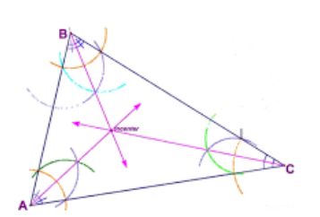  Example 2: Use a pair of compasses and a ruler to construct a triangle (say ABC) under a given condition, bisect at least any two angles (∆BAC and ∆BCA); locate the intersection of the two angle bisectors (L) and draw a locus of points equidistant from the fixed point (L) to touch the edges of the triangle.  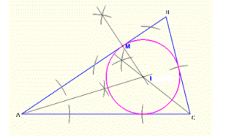  Present real-world scenarios where inscribed circles are used, like designing gears, building bridges, or calculating land area.  Ask learners to brainstorm other potential applications where knowing the inradius of a triangle could be useful. |  |  |  | manipulatives like counters or algebra tiles
PHASE 3: REFLECTION | Use peer discussion and effective questioning to find out from learners what they have learnt during the lesson.  Take feedback from learners and summarize the lesson.

Week Ending: |  | DAY: |  | Subject: Mathematics
Duration: 60MINS |  |  |  | Strand: Geometry & Measurement
Class: B9 |  | Class Size: |  | Sub Strand: Shapes and Space
Content Standard:  B9.3.1.1 Apply the properties of angles at a point, angles on a straight line, vertically opposite angles, corresponding, angles to` solve problems |  |  | Indicator:  B9.3.1.2.1 Draw inscribed and circumscribed circles for triangles under given conditions. |  |  | Lesson:  1 of 1
Performance Indicator:  Learners can apply the properties of circumscribed circles to solve related problems. |  |  |  | Core Competencies:  Communication and Collaboration (CC) Critical Thinking and Problem solving (CP)
References: Mathematics Curriculum Pg. 199
New words: Inscribed circle, Incenter, Radius, Tangent
Phase/Duration | Learners Activities |  |  |  | Resources
PHASE 1: STARTER | Imagine you're a medieval geometer exploring hidden castles. Each room boasts a majestic triangular window.  Can you draw a perfect circle inside each window, touching all three walls? How many ways can you do it?  Share performance indicators and introduce the lesson.
PHASE 2: NEW LEARNING | Briefly recap the concept of inscribed circles and introduce the idea of circumscribed circles - touching all three vertices of a triangle without going inside.  Show an example of a triangle with both inscribed and circumscribed circles.  Divide learners into pairs. Provide them with the same triangle templates from the previous lesson.  Challenge them to use compasses and rulers to draw circumscribed circles around each triangle. Encourage them to observe and discuss their findings.  Facilitate a class discussion to identify any patterns or similarities they observed. Guide them to discover:  - Some triangles cannot have a circumscribed circle (triangles with very large angles).  - Some triangles only have one possible circumscribed circle.  - All equilateral triangles have a circumscribed circle that passes through its centroid (the point where the medians intersect).  Once they've grasped the properties, introduce the formula for the radius of a circumscribed circle (circumradius) based on the triangle's side lengths (a, b, c): R = (abc) / (4√s(s - a)(s - b)(s - c)).  Example 1: Construct a triangle (say 𝐴BC); bisect all three sides (i.e. line segments 𝐴B, 𝐴C 𝑎and 𝐵𝐵); locate the intersection (circumcenter) of the three perpendicular bisectors (𝑆𝑆); Measure the distance from the intersecting centre (S) to points A, B and C. What do you observe about the lengths?  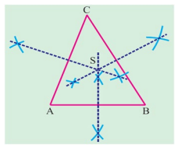  Example 2: Perform a geometric construction of a triangle (say 𝐴BC) under a given condition; bisect at least any two sides (𝐴B and 𝐵C); locate the intersection of the two perpendicular bisectors (𝑂) and draw a locus of points equidistant from the fixed point (𝑂) to circumscribe the triangle  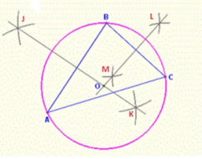  Explain the concept of semi-perimeter (s) and guide learners through practice problems using the formula.  Present real-world scenarios where circumscribed circles are used, like designing telescopes, building trusses, or calculating the area of a teardrop-shaped object.  Ask learners to brainstorm other potential applications where knowing the circumradius of a triangle could be useful. |  |  |  | manipulatives like counters or algebra tiles
PHASE 3: REFLECTION | Use peer discussion and effective questioning to find out from learners what they have learnt during the lesson.  Take feedback from learners and summarize the lesson.

